
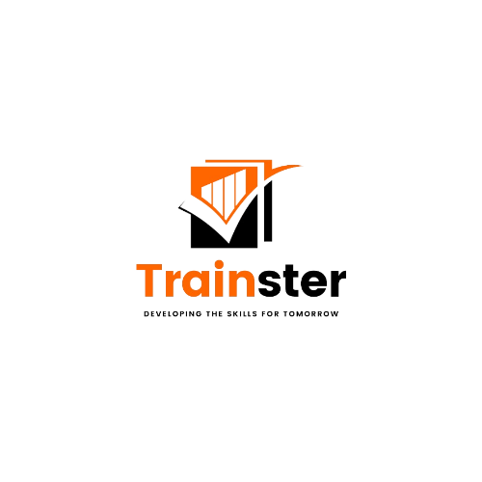

PROFILE

Table of

Contents

WHO WE ARE

WHAT WE DO

TESTIMONIALS

MISSION & VISION

PROPOSED TIMELINE

CONTACT INFO

03

04

05

06

08

09
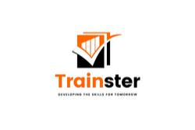



WHO WE ARE

Introduction

As a training Trainster Skills Development Institute is committed to ensuring that our material is relevant to our clients and that our delegates can practically apply the skills they have acquired in the workplace. Trainster Skills Development Institute, was registered in term of section 14 of the companies act 2008.and Registration No 2023/253405/07 with tax reference No 9256504268.
Trainster Skills Development Institute recognize that a solid foundation of employees with the right skills and knowledge increases an organization’s ability to achieve its mission. All prosperous societies place very high premium on education and Training and prepare citizens to become business and wealth creators. Trainster Skills Development Institute has built a reputation around its team’s dedication, performance, and collective innovation with decades of experience. We support delegates with intensive POE building. In the past few years, we have uploaded 200 assessment results – all of which have been endorsed. We have been complimented by SETA verifiers on our sound practices and professionalism.
Trainster Skills Development Institute offers training and development programs to help employees improve their skills and provides long-term support as new hires navigate their responsibilities.

Trainster Training and Skills Development Institute offers leadership development programs, employee development programs, and annual training for job skills.





WHAT WE DO

T. T. S. D. I STRATEGIC INTENT

“To provide relevant, innovative and demand-driven skills knowledge for socio-economic development.

TRAINING PROGRAMME HIGHLIGHTS

Trainster Training and Skills Development Institute has the experience in the following areas of Training and skills development programmes:

UPWARD FOR SUCCESS FOR COORPERATE:

- Analysis of Training & needs & providing feedback to clients
- Co-ordinate and facilitate company inductions for new employees,
- Team Leadership and Management
- Performance Management
- Effective Leadership Communications
- Project Management
- Effective Time Management
- Effective Negotiation Skills
- Stress Management
- Managing Conflict within the Workplace
- Plan and Manage Personal Finances
- Organising and Managing Meetings & Taking Effective Minutes

HYGIENE AND CLEANINING COURSES
- Training in Full Qualifications NQF level 1, 2 and
- 3 (Commercial Cleaning
- Generic Management 3 and 4, Business
- Customer Care Service Excellence
- Administration NQF level 3, Hygiene and Cleaning
- Supervision Business Practice & Retail shop floor
- Seta and skills programs)
- On site assessment
- Induct new staff member
- Complete Administration duties for Learnership,
- Skills programs and Short Courses.
- Uploads to Seta (Learner credits, assessment and moderation reports).
- The Fundamentals of Project Management
- Understanding HIV / AIDS
- Corporate Social Investment

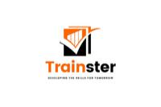



MISSION & VISION

STATEMENT

MISSION

“We believe that the growth and d of individuals is key to achieving succ success in
any industry or community

VISION


To develop the competitive advantage of Individuals individuals and organisations.

VALUES


Our corporate values are comprised of four core principles as indicated below.



EXCELLENCE

Commitment to excellence in facilitating and teaching, research, and community service, aiming for superior standards.

CREATIVITY & INNOVATION

We shall search and research for and apply new or novel ideas, methods and practices in our areas of operation.

EQUITY
The organization aims to establish a fair, just, and
impartial culture in all dealings to affect the
behaviour of its staff towards clients & stakeholders.

INTEGRITY
We shall continue to be consistent in our actions
and will conduct ourselves in accordance to our
values, beliefs and principles.

GIVING

BACK

COMMUNITY OUTREACH, CORPORATE, COMMUNICATION AND KNOWLEDGE MANAGEMENT

Trainster Training and Skills Development Institute believe that any organisation that aspires to offer a product or a service and achieve a goal must connect with the community in some way. This is premised on the understanding that communities are the ultimate beneficiaries of all social and economic activity outputs.
Trainster Training and Skills Development Institute runs Cooperate and community programmes at various levels. These programmes offer people the opportunity to develop essential skills, leadership, management, and business knowledge that they need to survive in a difficult economic environment by becoming self-employed and thus alleviating part of the problem of unemployment. Through the training intervention, participants can impact positively on the community when the demonstrated success of new skills leads to changes in perceptions and behaviours of others.
COPERATE SOCIAL INVESTMENT COMMUNITY DEVELOPMENT PROGRAMMES
  - Developing School Governance Bodies in Several Provinces.
  - Organisational and Development support to Rural Development Committees
  - Development of Farmers Associations in Namibia, Malawi and East African countries
  - Development of Farmers Associations in Mpumalanga and KZN Provinces.
  - Development of youth Leadership and Life skills.
  - Capacity Building training of Agriculture and Dairy farmers on behalf of F.A.O/ U.N in Swaziland.
  - Development of Community facilitation skills in provincial and municipal departments in Gauteng, Western Cape, Kwa-Zulu Natal and North -West Provinces.
In all these activities, knowledge management will be a key factor to consider because corporate communication is the fundamental anchor through which corporate activities are projected to the public. Trainster Training and Skills Development Institute Innovative approach has meant the difference between success and failure for many entrepreneurs.

.

ABOUT THE FOUNDER.

GEOFFREY LUKAS PHIRI

Geoffrey Lukas Phiri is the Director of Trainster Training & Skills Development Institute, has 30 years of experience in Training and Skills Development he has worked in all the 9 provinces of south Africa and SADC countries. He has contributed to creating a spirit of good governess and enterprise through networking with decision makers and provision of knowledge and skills that will allow the people and organisation to prosper
He currently serves as member of the Hiring and cleaning chamber committee for the servceseta, sits on the board of the professional body of the PBEH of the South Africa. Board Member of the Free-Market Foundation and Member of the Institute of people Management of South Africa,



www.trainster.co.za


info@trainster.co.za

